5. Shopping
In Birobidzhan, you can find a wide variety of places to do the shopping. In Sholom-Aleichem Street you will find many shops selling clothes and food. You can also find them at Giant, Gigant, Top City and Bira City shopping centres. Shopping malls are open from 10 am to 8 pm.
If you are looking for something cheaper, you can visit the Central Market. However, it tends to be crowded there.
Central Market is located in Sholom-Aleichem Street. You can find everything there, all kinds of clothes, shoes, bed linen, table linen, and food. The market is open from 10 a.m. to 4 p.m. You can get there from the University by bus.
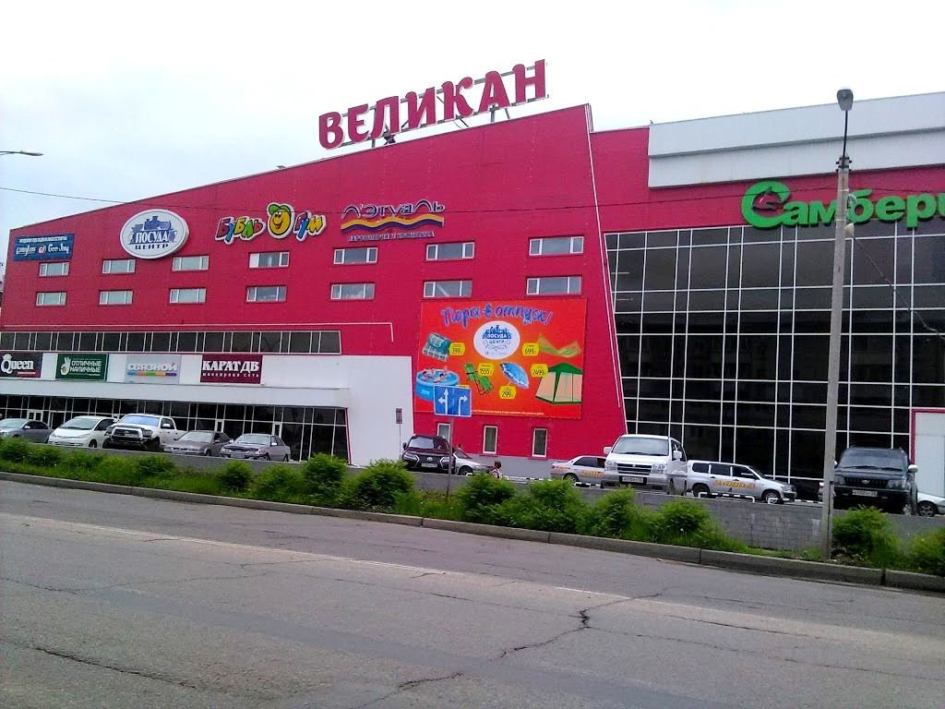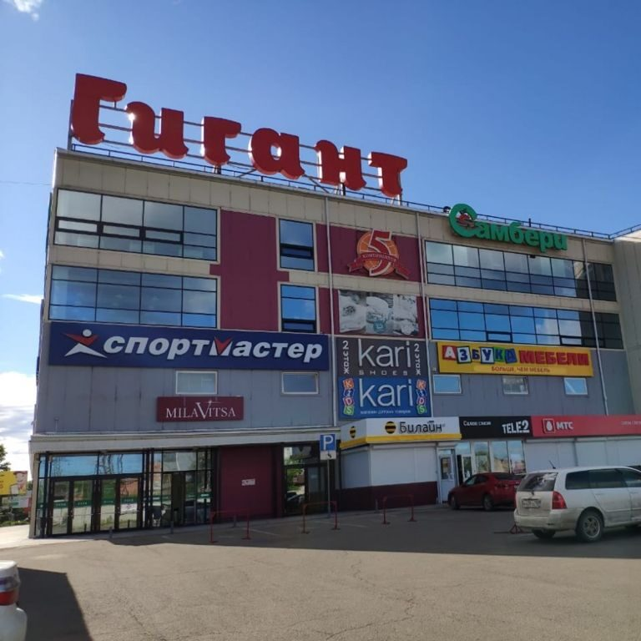
Money, tips
Money
If you do not want to carry cash with you, you can buy a Visa or Mastercard at a bank in your home city. You can find an ATM everywhere in the city.
You can use your card to pay in most supermarkets and boutiques.
Exchange offices can be found at most banks.
Tip
Tipping for service is not a rule in Russia. It is common to tip in restaurants and cafes; if it is not mentioned, then a tip (10%) is included in the bill. Otherwise, you may leave 10-15% of the bill for the waiter (waitress) who served you before you leave.
It is not common to leave a tip in fast food cafes and places where self-service is offered. It is also not acceptable to tip taxi drivers or porters at the airport.
Never offer a tip to officials, police or civil servants, or to hotel staff, public transport check-takers, doormen or aircraft attendants.

